
A 10
Sreenidhi Institute of Science & Technology
(An Autonomous Institution)
Code No: 101MA02/111MA02

B. TECH. I – Year I – Semester Examinations, May, 2012 (Supplementary)
Mathematics for Biotechnology - I ( BT )

Time: 3 Hours Max. Marks : 70

Note : No additional answer sheets will be provided.

Part-A (Objective Type)
Max. Marks : 20

Answer all QUESTIONS.

1. Evaluate cosh²x - sinh²x.
2. Find the slope of the straight line 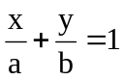.
3. Find the center of the circle x²+y²-2x-2y+1=0.
4. Evaluate 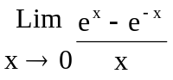.
5. Find 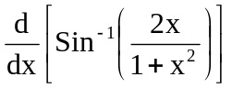.
6. Find whether 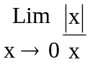 exists or not.
7. Find the subnormal at any point of the parabola y²=4ax.

8. If u=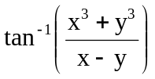, x≠y, show that x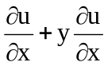=2u.
9. Find the maximum and minimum values of the function f(x)=8x⁵-15x⁴+10x².

10. Evaluate 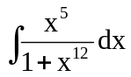.
Part – B
Max. Marks: 50
ANSWER ANY FIVE QUESTIONS. EACH QUESTION CARRIES 10 MARKS.

1. a) Find cube roots of unity. [ 6 ]
b) Show that tan 2θ=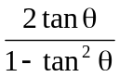. [ 4 ]
2. a) Find the equation of the straight line passing through (1,1) and perpendicular to x+2y+3=0. [ 5 ]

b) Find the center and radius of the circle x²+y²-2x-2y-14=0. [ 5 ]

3. a) Find [ 5 ]
i) 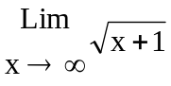 ii) 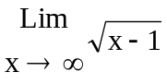
iii) 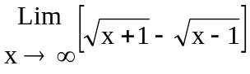
b) Discuss the differentiability of f(x)=|x| at x=0. [ 5 ]

4. a) Show that a function derivable at a point is continuous at that point. [ 5 ]

b) Discuss the continuity of the function f(x)=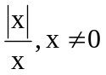at x=0 given f(0)=0. [ 5 ]

5. a) Find the equation of the tangent to the curve y=5x⁴ at (1,5). [ 5 ]

b) Find the derivative of y=x^{x}. [ 5 ]

6. a) If 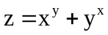, then find 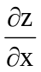,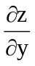. [ 5 ]

b) If z= f(x+ay) + φ (x-ay), prove that 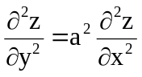 . [ 5 ]
7. a) Find the maximum and minimum values of f(x)=8x⁵-20x⁴+10x³. [ 5 ]

b) If z(x+y)= x²+y², show that 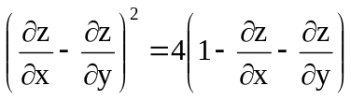. [ 5 ]

8. a) Find 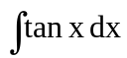. [ 4 ]
b) Evaluate 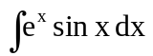. [ 6 ]

-- 00 -- 00 --

